Assignment Submission Report
Name: Charles Taggart
Course / Cohort: FSDI 110 / Cohort 65
Assignment: Assignment 1 – RESTful API
GitHub Repository Link:

Evidence of Functionality

Frontend/UI
Attach 3 screenshots only:
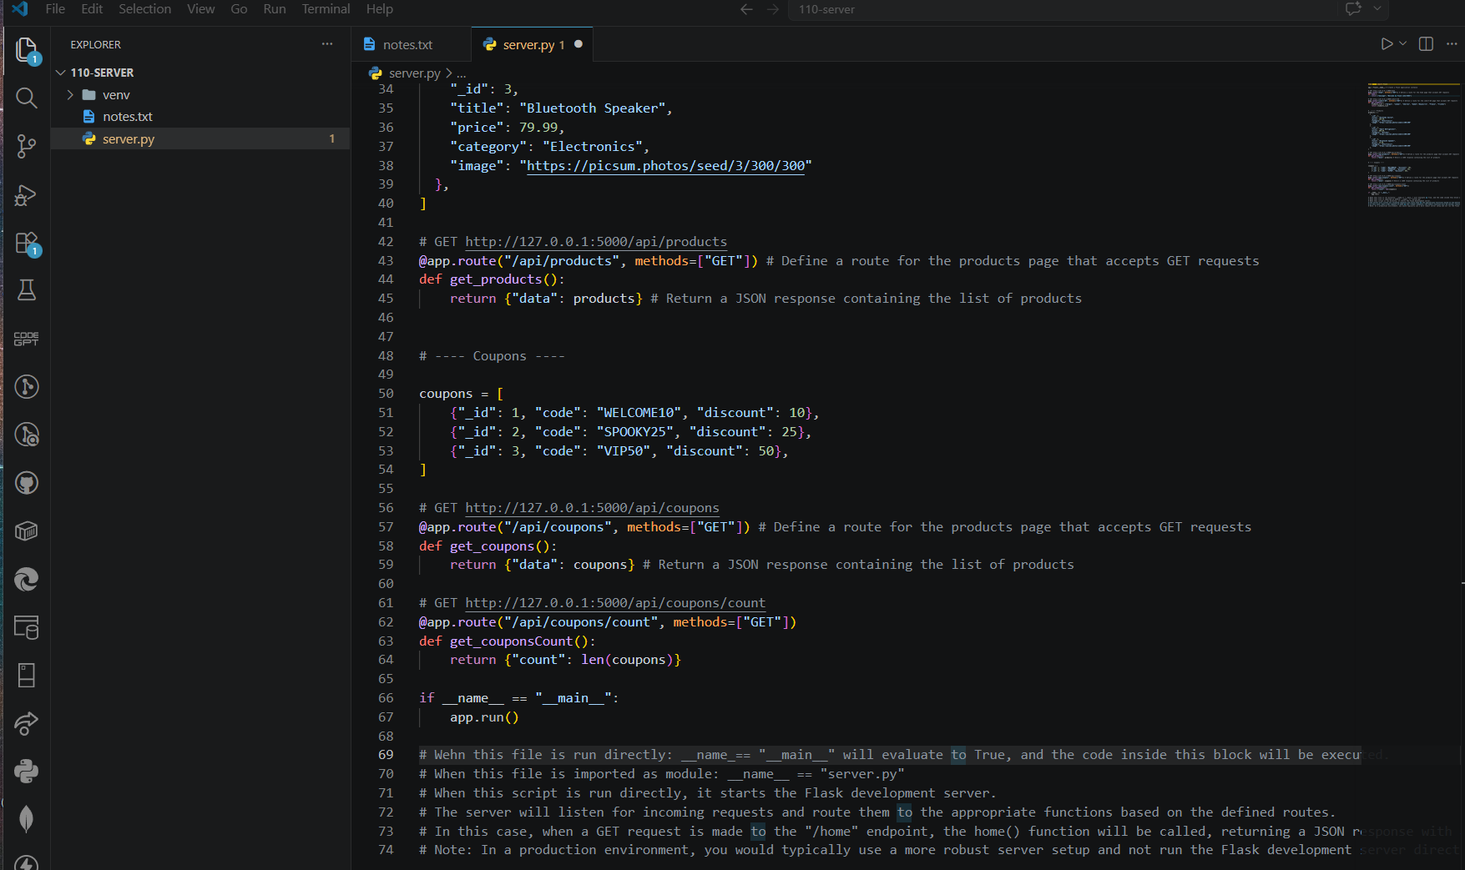
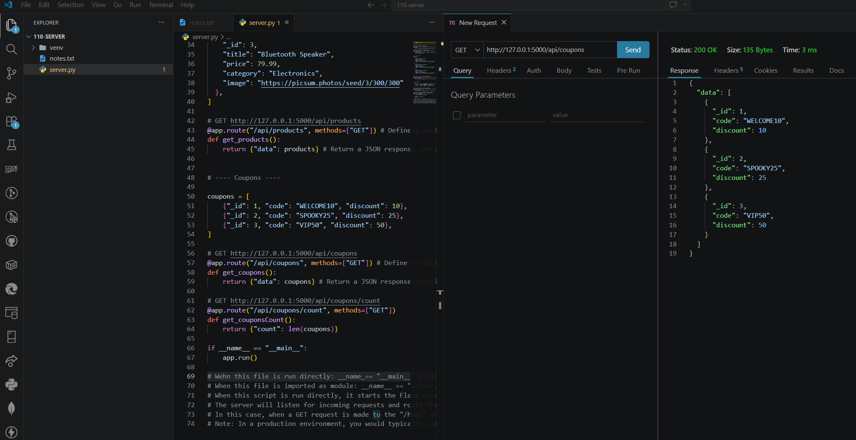
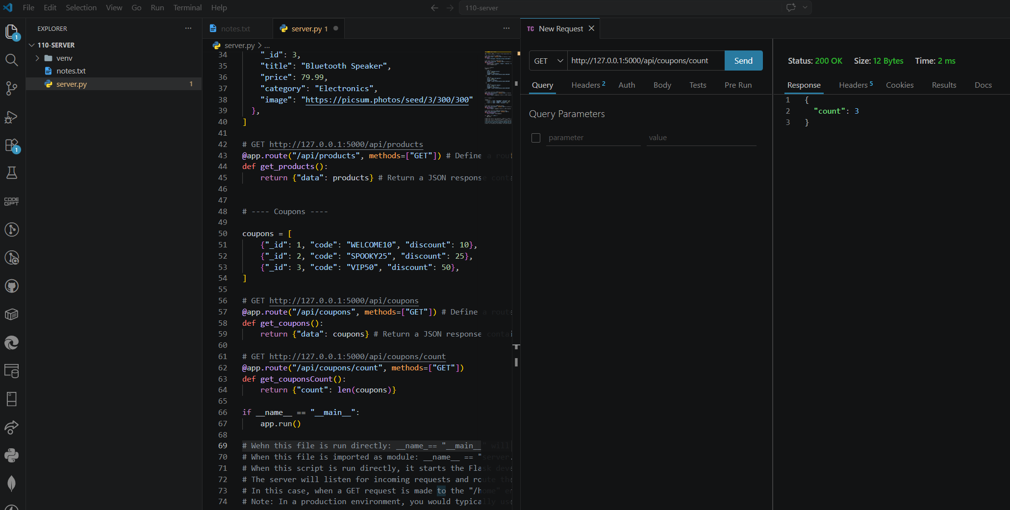
Backend/Logic
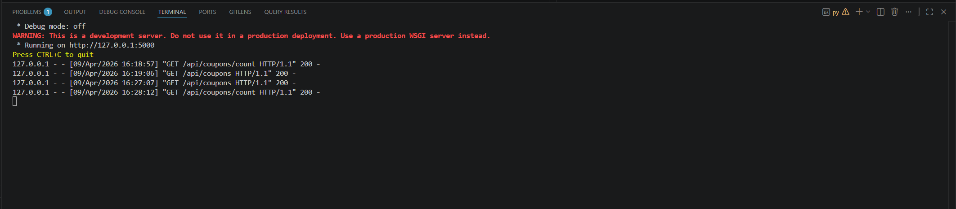
AI Disclosure (Required) – Highlight the one that applies
- I did not use AI
- I used AI for help
- AI generated parts of my code

